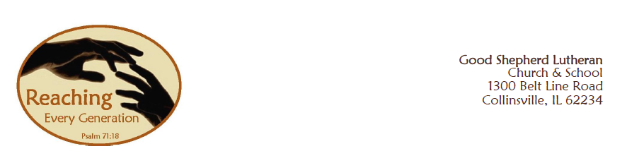

Dear Parents,

I trust that you are settling in to a nice routine now that we are well into the first quarter of the school year. I pray that the foundation of faith that your children are receiving at Good Shepherd is evident in their daily lives and that you are seeing the value of a Christian education.

I want to share with you some exciting news about what is happening at Good Shepherd. The congregation is expanding our ministry. Our vision is to reach every generation for generations to come with interconnected ministries in the Word of God. In order to do that the congregation and leadership teams have prayerfully looked to Jesus and made a decision to move forward with a capital campaign designed to call all of us to sacrificial giving for the sake of generations of our children.

Our mission is to raise initial capital for a facility expansion that will integrate our early childhood center into the main campus and expand our reach into the community. As we consider this building program, we turn to Jesus and to all of God’s word for our faith and for our strength to serve Him in many ways.

I would like to invite you to learn more about this exciting endeavor by attending a presentation at Good Shepherd Church on Tuesday, October 15, 2013 at 7:00 p.m. Once you have listened to the presentation, I am asking that you prayerfully consider participating with all of us in giving generously to God’s mission for our children, in order to support our children for generations to come.

I would also like to remind you that if at least one parent attends the meeting your children will be allowed to wear jeans on Wednesday, October 15, 2013.

Sincerely,

Katie Robinson

Friends of the Congregation Director