Good Shepherd Lutheran Church and School
1300 Belt Line Road Collinsville, Illinois 62234
Church: (618) 344-3151 www.gslcs.org School: (618) 344-3153
Fax: (618) 344-3378 Fax: (618) 344-3156

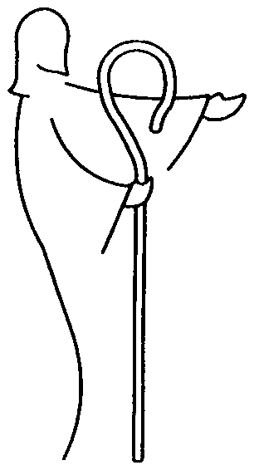

I am the Good
Shepherd. The
Good Shepherd
gives His life for
the sheep.
- John 10:11

Pastor:
Michael Walther
618-344-3151

Pastor:
Scott Adle
618-344-3151

Principal:
Robert Mayhew
618-344-3153

Parish Administrator:
Marty Hoffman
618-344-3151

Dear Parents of students entering kindergarten, second and sixth grade:

Illinois State Examination Requirements

Examinations shall be required of students as are required by the Illinois State Law. Verification of such must be provided to the school on the form provided by the State of Illinois. Requirements, forms and wavers are available on the Illinois Department of Health (www.idph.state.il.us), the Illinois State Board of Education (www.isbe.net.), and Good Shepherd Lutheran School (www.gslcs.org) websites.

- Physical Examination and Immunizations:
All students entering kindergarten, sixth grade and new students entering Illinois schools for the first time will be required to have proof of a physical examination, protection from communicable disease, and vision and hearing screening performed and signed by a licensed physician. Record shall be provided on the State of Illinois Child Health Examination Form.
Students entering sixth grade are required to have two booster vaccinations called Tdap and Meningococcal.

- Dental Examinations:
All students entering kindergarten, second and sixth grade and new students entering Illinois schools for the first time will be required to have an oral health examination. The required examination must be performed by a licensed dentist and he/she shall sign the State of Illinois Dental Examination Form.

- Eye Examinations:
All students entering kindergarten and new students entering Illinois schools for the first time are required to present proof of an eye examination by an optometrist or medical doctor who performs eye examinations, as specified in the Illinois Department of Public Health administrative rules. He/She shall complete and sign the Illinois Eye Examination Report Form.

The attached forms may be mailed to the school office or turned in by the first day of school in August.

Robert Mayhew, Principal

